Operations & supply chain management

Table of Contents
1. Introduction 5
Organisation and Supply Chain Context 6
Key Challenges and Report Focus 6
2. Supply Chain Theoretical Framework 7
Lean Supply Chain 7
Agile Supply Chain 8
Interrelationship Between Lean and Agile 8
Key Supply Chain Drivers 9
AI, Automation and Digital Supply Chain 10
3. Specific Supply Chain Analysis 11
Supply Chain Mapping and Strategic Context 11
Economic Analysis 11
Social Analysis 12
Environmental Analysis 13
Integrated Critical Evaluation 14
4. Recommendations for Supply Chain Improvement 15
AI-Enabled Supply Chain Visibility 15
Intelligent Automation 15
AI-Based Supplier Sustainability and Risk Monitoring 15
Supplier and Stakeholder Collaboration 16
Implementation and KPIs 16
5. Conclusion 18
Key Findings 18
Sustainability and Ethics 18
Recommendations 18
Recommendation 1: Digital Supply-Chain Transformation 18
Recommendation 2: Collaborative Sustainable Supply-Chain Management 19
Final Reflection 19
References 20

List of figures

Figure 1: Nestlé brand logo 5
Figure 2: Lean supply chain dimensions 7
Figure 3: Key characteristics of an agile supply chain 9
Figure 4: Triple Bottom Line and ESG 14

List of tables
Table 1: Implementation and KPIs 16

1. Introduction
Operations management is concerned with the management and planning of the activities that are employed in producing and delivering goods and services. Supply chain management (SCM) is concerned with the flow of materials, information and products between suppliers and customers (Aliahmadi et al., 2022). The importance of SCM to global food and beverage companies is that supply chains come with a variety of suppliers, production locations, logistics service providers and retailers. Lack of coordination may raise costs, introduce delays, diminish the availability of products and undermine customer confidence.
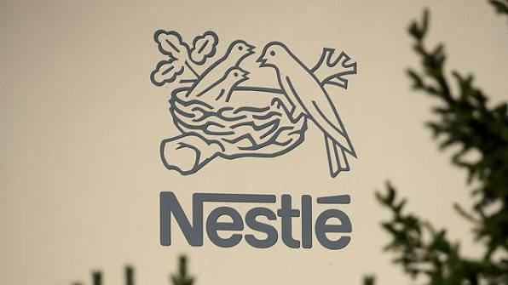
Figure 1: Nestlé brand logo
(Source: BBC, 2026)

Organisation and Supply Chain Context
This report deals with Nestlé UK and explores a confectionery supply chain of choice. This process starts with suppliers of raw materials and ingredients; this will then be processed into manufacturing, warehousing and distribution to retailers, e-commerce outlets and consumers. Value creation is achieved by sourcing reliably, producing efficiently, maintaining quality, and making products available to customers promptly (Bačiulienė et al., 2023). This complicated network, however, becomes vulnerable to the cost pressures of procurement, a shift in supplier provision and consumer buying.

Key Challenges and Report Focus
Nestlé UK also has to deal with the environmental pressure associated with: carbon emissions, packaging, resource utilisation and waste. These issues demonstrate that cost alone cannot be used as a central element of supply-chain decisions. The report thus assesses the Lean and the Agile approaches to supply chains and analyses what drives the cost, quality, speed, flexibility and sustainability. It also takes into consideration the possibilities in relation to AI, automation and digital supply-chain systems enhancing forecasting, visibility and decision-making.

2. Supply Chain Theoretical Framework

Lean Supply Chain
The lean supply chain aims at value generation and eliminating non-value-adding activities. The core values consist of reducing waste, managing inventory efficiently, reducing costs and continuous improvement. In the case of Nestlé UK, lean ideas can be used to implement the Nestlé confectionery supply chain to help the company manage the stocks of raw materials, cut unnecessary transactions and enhance efficient production and better distribution (Nestlé Cocoa Plan, 2024).
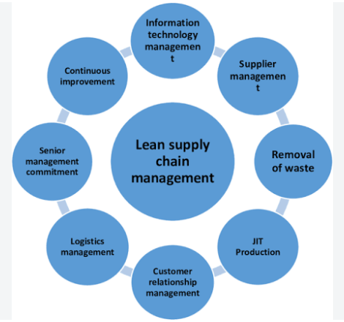
Figure 2: Lean supply chain dimensions
(Source: Nozari and Aliahmadi, 2022)
To give a case in point, less chocolate, sugar and even packaging materials can be wasted as far as production can be carried on. It is possible, however, to enhance efficiency and competitive pricing using lean methods. Lean supply chains, however, are also fraught with weaknesses. Should Nestlé trim inventory and expenditures excessively, it could leave itself vulnerable to sudden increases in delays, transportation hiccups or shortages on the part of suppliers.

Agile Supply Chain
Agile supply chain remains flexible to speed and reactiveness to changes. This matters to Nestlé UK since the demand for confectionery may vary with season, promotions, consumer tastes, and changes in the market caused by unforeseen circumstances. Nestlé can also use an agile approach to adjust production and swiftly replenish products in response to supply disruption (Batrisyia and Fernando, 2024). To illustrate, when demand is high, alternative suppliers and flexible production can be used in order to ensure that products are available when a supplier cannot supply the products. Agility, however, may also escalate cost due to the fact that the company might require more production capacity, backup suppliers, safety stock and flexible transport arrangement.

Interrelationship Between Lean and Agile
There are differences between the purposes of lean and agile, which are complementary. Agile and lean are complementary; lean is primarily focused on efficiency, reduction of costs and wastes and agile is primarily focused on flexibility, speed and responsiveness (Belhadi et al., 2024). In the case of Nestlé UK, lean may pose issues when applied solely because, when inventory levels are too low, the confectionery supply chain becomes less capable of withstanding disruption.
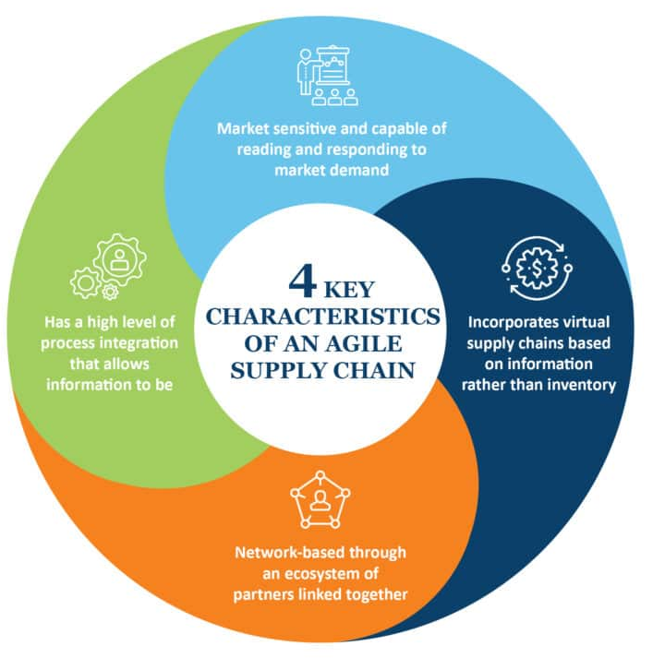
Figure 3: Key characteristics of an agile supply chain
(Source: Taylor, 2024)
On the contrary, pure agility might make operating costs higher due to additional capacity, suppliers, and inventory. A lean-agile balance is a better solution, however. Nestlé is able to apply lean practices when the demand and processes are reasonably predictable, e.g., regular production and established distribution processes (Zhou et al., 2024).

Key Supply Chain Drivers
Supply-chain decisions are closely coupled with cost, quality, speed, flexibility and sustainability. Reduced procurement, manufacturing, inventory and logistics costs can enhance profitability, but too much cost reduction will compromise quality or flexibility (Dewi, Hendayani and Shaharudin, 2025). Quality is particularly essential to Nestlé since food safety, product consistency and trust from customers should be secured. Speed is a factor as well since any delay may cause empty shelves and lost sales. But quicker delivery can involve providing costly transport. Flexibility assists Nestlé in keeping up with fluctuating demand and disruption, whereas keeping extra capacity or other suppliers may be expensive.

AI, Automation and Digital Supply Chain
Digital technologies can enhance the supply chain of Nestlé UK, and specifically, they can bridge the information amongst suppliers, factories, warehouses and retailers in real-time. This will enhance network visibility and coordination. Better planning can be encouraged with the help of AI demand forecasting, predictive analytics and real-time visibility. Speed and accuracy may be enhanced by the use of automated warehouses and robotics, and risks may be detected earlier through the use of digital monitoring of suppliers (Dora et al., 2022). Nonetheless, these technologies pose their own problems as well. Shoddy data may lead to incorrect decision-making, and cybersecurity issues can cause havoc to operations. The process of automation also might alter job roles and enhance the necessity of employee reskilling. Nestlé should thus take into account technology reliance and ethical human-AI decision-making. Digital transformation must assist individuals, healthiness and durability as opposed to efficiency alone. Nestle UK already incorporates digital supply-chain, digital planning and data-driven planning; extending AI forecasting, automated warehousing and real-time supplier monitoring would enhance further visibility, responsiveness and resilience (Lysons, and Farrington, 2020).

3. Specific Supply Chain Analysis

Supply Chain Mapping and Strategic Context
The selected confectionery product is Nestlé UK’s KitKat. The confectionery supply chain at Nestlé UK starts with the suppliers of the raw materials who supply the firm with some of the most important inputs, including cocoa, sugar, milk ingredients and other agricultural products. These resources pass up the chain of ingredient suppliers and packaging suppliers into the manufacturing processes of Nestlé. Goods are subsequently fabricated, packaged and stored in warehouses where they are shipped via distribution channels and delivered to supermarkets, retailers and over the internet to the consumer (Dubey et al., 2022). Value: the raw materials are converted into safe, consistent and branded products that are bought by the customers. Nevertheless, every step poses some possible risk as well. Climate change can influence cocoa and other farm products; bad harvests, fluctuations in prices, and transportation problems may postpone shipments. This implies that what is efficient in one aspect may result in a deficiency in another.

Economic Analysis
To stay profitable, Nestlé UK needs to work on procurement, manufacturing, inventory, warehousing and transportation cost control. The large numbers of products purchased and the economies of scale acquired by large factories can decrease the average cost of production (El Jaouhari and Hamidi, 2024). Nevertheless, economies of scale may also bring about reliance on high-volume activities. In case one of the key facilities or suppliers is disrupted, the financial blow can be more significant since a larger share of the supply chain could be affected.
Another significant trade-off is provided by inventory. Maintaining a smaller stock level enables a lean strategy because it minimises stocking expenses and time and increases savings. Nevertheless, disruption is likely to become more expensive when the inventory levels are very low since the company might not be able to satisfy the demand in the case of a disrupted delivery (Glorius-Dangelo, 2023). The inventory savings in this case can be less than the sales and reputation losses due to a lack of products.
The same is the case for transportation. Lower transport costs can save short-term expenses but have less flexibility in cases of disruption. Alternative methods, like alternative transport options or extra suppliers, are more expensive but can be used to safeguard the availability of products. So, nestlé cannot use lean techniques throughout the entire supply chain. Lean practices apply in cases where demand and supply can be anticipated, whereas increased agility is warranted in case of high-risk materials and activities.

Social Analysis
The element of social performance plays a crucial role in the supply chain of Nestlé since the enterprise relies on the massive networks of suppliers, workers, and farmers. The responsibility and fair treatment of workers, as well as responsible labour practices, can have an impact on ethical performance and the reputation of the business (Hatif, Lee and Nawanir, 2024). Special focus is placed on cocoa sourcing since agricultural supply chains may entail severe labour and human-rights threats.
This presents a challenging price-responsible sourcing trade-off. Supplier price can be economically competitive, but may place suppliers under stress and can lead to poor labour practices. Meanwhile, when a problem is identified by merely changing the supplier, it may not address the bigger picture since another supplier will be challenged. Auditing of suppliers is important but not adequate.
Supplier development is a better way. Nestlé can collaborate with suppliers over time via training, clear standards, observation and encouragement to improve. This will result in increased short-term expense but is likely to result in improved labour practices and less volatile supplier relationships. It also minimises the risk of constantly switching suppliers (Kurniawan and Fernando, 2023). Thus, ethical sourcing cannot be considered merely as a cost. It is capable of providing continuity in supplies, trust and brand image among the stakeholders. This does not go against SDG 8, which revolves around decent work and economic growth (Nestlé Cocoa Plan, 2024).

Environmental Analysis
The Nestlé confectionery supply chain has environmental impacts that include agricultural production, production, transportation, energy, packaging, consumption of water and waste. Such effects also have the potential to cause direct business risks (Mohaghegh and Größler, 2025). Take climate change; it can lower agricultural outputs and raise the cost of raw materials or their supply.
Another obvious trade-off would be on packaging. Packaging of confectionery is needed to preserve quality and sustain shelf-life; however, too much packaging, or packaging that is hard to recycle, puts extra strain on the environment. Bare removal of the packaging would thus generate other issues, like damage to the product and waste of food.
The same trade-off is established by energy efficiency. The cost of implementing efficient equipment or renewable energy can raise capital expenses in the short term, but decreases expenses and energy consumption, along with emissions, in the long term (Nozari and Aliahmadi, 2022). But it implies that the value of the environmental investment has to be estimated in terms of the direct financial expenses as well as indirect operational gains in the future. This action can support SDG 9 by means of innovation and sustainable infrastructure, SDG 12 by responsible production and the use of resources, and SDG 13 by climate action.
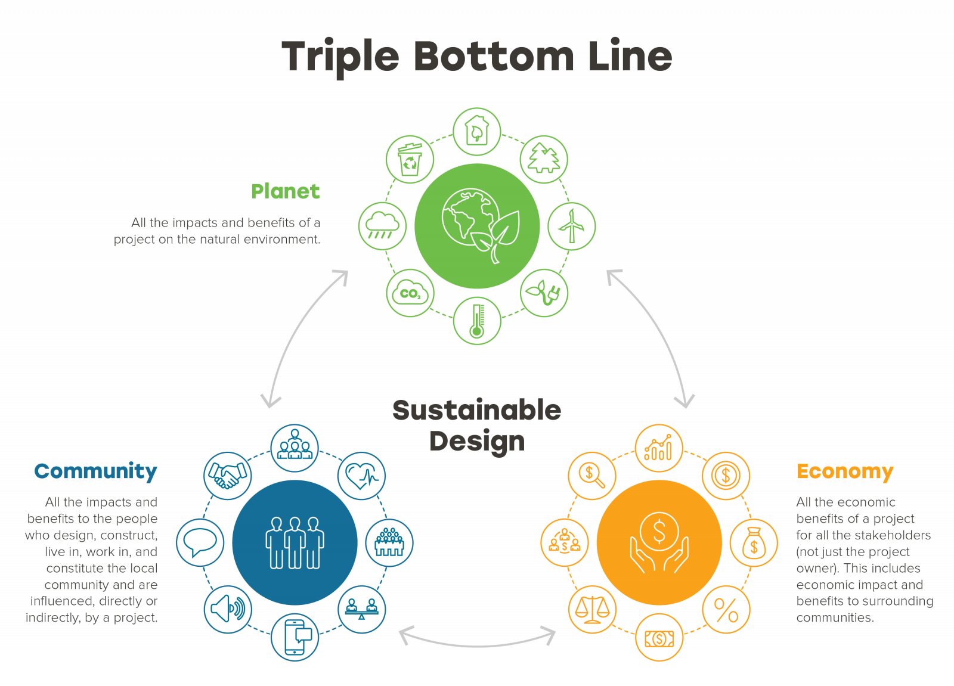
Figure 4: Triple Bottom Line and ESG
(Source: Glorius-Dangelo, 2023)

Integrated Critical Evaluation
The Triple Bottom Line reveals that Nestlé is unable to optimise its success in economic terms, neglecting its social and environmental impacts. Reduced costs may decrease resilience or ethical practices, whereas increased growth may boost environmental effects.

4. Recommendations for Supply Chain Improvement

AI-Enabled Supply Chain Visibility
Nestlé UK needs to install an AI-powered control tower that will combine supply, demand, logistics, and risk data. The early detection of changes in demand for confectioneries would be achieved through AI demand forecasting, and early real-time monitoring would enhance the visibility of the network (Nozari and Aliahmadi, 2022). Forecast warnings might be made on any supplier’s lag or transport interruption before service levels are impacted. Optimisation of inventory may decrease surplus inventory whilst ensuring availability. This is helpful in lean SCM since waste is minimised and agile SCM since it advances responsiveness, flexibility and resilience.

Intelligent Automation
At Nestlé UK, intelligent automation in warehousing, inventory management, order and logistics planning, and repetitive activities which cause delays should be introduced. Speed, accuracy and efficiency could be enhanced by automated picking, route planning, and AI-based solutions. Automation is not to become, though, a work-saving programme (Oliveira-Dias, Maqueira Marín and Moyano-Fuentes, 2022). Implementation should be supported by employee consultation, reskilling and training, allowing employees to transition to high-value jobs.

AI-Based Supplier Sustainability and Risk Monitoring
To enhance its responsibility in sourcing, Nestlé UK needs to create a digital supplier-monitoring system that evaluates the performance of the company in terms of ESG, labour, environmental performance, sourcing risks and compliance (Piotrowicz, Ryciuk and Szymczak, 2023). Supplier data may create risk scores and early warnings, which can be used to enable procurement teams to prioritise action. This contributes to SDGs 8, 12 and 13 by enhancing labour practices, efficiency of resources and climate responsibility.

Supplier and Stakeholder Collaboration
Nestlé UK needs to enhance cooperation with suppliers, logistics suppliers, retailers, employees and technology suppliers on mutual information platforms. IBM FAMP is able to enhance the visibility of demand at a joint forecasting level, and shared disruption plans can help to define responsibilities in the case of disruptions. Sustainability goals should be agreed on by partners in terms of emissions, waste, and responsible sourcing (Raman, Mahmud and Shaharudin, 2023). Capabilities can be enhanced rather than substituted by means of supplier-development programmes.

Implementation and KPIs
The confectionery supply-chain areas with the highest risk should be implemented first, followed by controlled pilots, assessment and expansion (Samuels, 2025). The following KPIs should track performance:
Table 1: Implementation and KPIs
(Source: Self-generated)
Area | Example KPI
Cost | Supply-chain cost per unit
Speed | Order fulfilment time
Flexibility | Forecast-response time
Sustainability | CO₂ emissions
Waste | Packaging/material waste
Social | Supplier compliance rate
Technology | Forecast accuracy
Altogether, these recommendations combine lean waste reduction and agile responsiveness, digital transformation and ethical SCM. They can assist Nestlé UK to become efficient and enhance resilience, sustainability and competitiveness.

5. Conclusion

Key Findings
The report indicated that the supply chain of Nestlé UK confectionery relies on coordinated flows of raw materials and packaging suppliers to manufacturing through warehousing, logistics and retailers. Lean SCM is able to minimise waste, inventories and unneeded activities, whereas Agile SCM can provide immediate responses to changes in demand and interruptions. Cost, speed, flexibility and resilience are directly impacted by the five supply-chain drivers: facilities, inventory, transportation, information and sourcing. Forecasting can be reinforced by AI and automation, yet their meaningfulness requires well-established data and reasonable human management.

Sustainability and Ethics
Economic efficiency alone cannot be used to measure supply-chain performance. Nestlé UK is forced to negotiate between reducing costs and protecting workers, sourcing its products ethically, being environmentally friendly and having no negative impact on the environment (Shanmugamani and Mohamad, 2023). The long-term environmental strains are due to carbon emissions, material waste, and resource consumption.

Recommendations

Recommendation 1: Digital Supply-Chain Transformation
To enhance forecasting, optimisation of inventory, disruption identification and efficiency in logistics, Nestlé UK needs to combine AI-powered visibility with intelligent automation (Taylor, 2024). Nonetheless, employee training and human control should be implemented to ensure responsible digital transformation.

Recommendation 2: Collaborative Sustainable Supply-Chain Management
Nestlé UK ought to enhance supplier tracking and partnership with suppliers, logistics suppliers and retailers (Zambujal-Oliveira and Fernandes, 2024). Ethical sourcing, resilience, carbon performance and waste reduction can be enhanced through shared sustainability targets, monitoring compliance and evaluation on the basis of KPI.

Final Reflection
Finally, Nestlé UK should be able to be competitive over the long run, not just on the cost and efficiency of its operations, but also on the strength, ethics, habits of environmental responsibility, and responsible digitalisation. Being passionate about combining Lean and Agile principles and technology, collaboration and sustainability can consequently develop an even more efficient, adaptable and responsible supply chain.

References
Aliahmadi, A., Nozari, H., Ghahremani-Nahr, J. and Szmelter-Jarosz, A. (2022) 'Evaluation of key impression of resilient supply chain based on artificial intelligence of things (AIoT)', arXiv preprint, arXiv:2207.13174. Available at: https://arxiv.org/abs/2207.13174 (Accessed: 14 September 2026).
Bačiulienė, V., Bilan, Y., Navickas, V. and Civín, L. (2023) 'The aspects of artificial intelligence in different phases of the food value and supply chain', Foods, 12(8), 1654. Available at: https://www.mdpi.com/2304-8158/12/8/1654 (Accessed: 14 September 2026).
Batrisyia, N.A. and Fernando, Y. (2024) 'Improving a circular reverse logistics to handle product return: insights from a global electronics services provider', International Journal of Industrial Management, 18(2), pp. 91–104. Available at: https://journal.ump.edu.my/ijim/article/view/10831 (Accessed: 14 September 2026).
BBC (2026) [Programme title]. Available at: https://www.bbc.co.uk/programmes/w172xkb1f957ytj (Accessed: 14 September 2026).
Belhadi, A., Mani, V., Kamble, S.S., Khan, S.A.R. and Verma, S. (2024) 'Artificial intelligence-driven innovation for enhancing supply chain resilience and performance under the effect of supply chain dynamism: an empirical investigation', Annals of Operations Research, 333(2), pp. 627–652. Available at: https://link.springer.com/article/10.1007/s10479-021-03956-x (Accessed: 14 September 2026).
Dewi, N.P.W.N., Hendayani, R. and Shaharudin, M.S. (2025) 'The impact of green supply chain management practices on sustainable development goals: a case of PT PJP in the energy sector', International Journal of Industrial Management, 19(3), pp. 155–164. Available at: https://journal.ump.edu.my/ijim/article/view/13224 (Accessed: 14 September 2026).
Dora, M., Kumar, A., Mangla, S.K., Pant, A. and Kamal, M.M. (2022) 'Critical success factors influencing artificial intelligence adoption in food supply chains', International Journal of Production Research, 60(14), pp. 4621–4640. Available at: https://www.tandfonline.com/doi/abs/10.1080/00207543.2021.1959665 (Accessed: 14 September 2026).
Dubey, R., Bryde, D.J., Dwivedi, Y.K., Graham, G. and Foropon, C. (2022) 'Impact of artificial intelligence-driven big data analytics culture on agility and resilience in humanitarian supply chain: a practice-based view', International Journal of Production Economics, 250, 108618. Available at: https://www.sciencedirect.com/science/article/pii/S0925527322002018 (Accessed: 14 September 2026).
El Jaouhari, A. and Hamidi, L.S. (2024) 'Assessing the influence of artificial intelligence on agri-food supply chain performance: the mediating effect of distribution network efficiency', Technological Forecasting and Social Change, 200, 123149. Available at: https://www.sciencedirect.com/science/article/pii/S004016252300834X (Accessed: 14 September 2026).
Glorius-Dangelo, J. (2023) 'Making the business case for triple bottom line and ESG', MA Design, 9 March. Available at: https://designwithma.com/insights/making-the-business-case-for-triple-bottom-line-and-esg/ (Accessed: 14 September 2026).
Hatif, H., Lee, K.L. and Nawanir, G. (2024) 'Improving employee and workplace performance via lean manufacturing practices: a case study in textile company', International Journal of Industrial Management, 18(1), pp. 43–59. Available at: https://journal.ump.edu.my/ijim/article/view/10425 (Accessed: 14 September 2026).
Kurniawan, I. and Fernando, Y. (2023) 'Circular economy supply chain for sustainable development goals (SDGs): a review and future opportunities', International Journal of Industrial Management, 17(1), pp. 32–39. Available at: https://journal.ump.edu.my/ijim/article/view/9211 (Accessed: 14 September 2026).
Lysons, K. and Farrington, B. (2020) Procurement and Supply Chain Management. Harlow: Pearson
Mohaghegh, M. and Größler, A. (2025) 'Leagile supply chains and sustainable business performance: application of total interpretive structural modelling', Production Planning & Control, 36(8), pp. 1087–1109. Available at: https://www.tandfonline.com/doi/abs/10.1080/09537287.2024.2344063 (Accessed: 14 September 2026).
Nestlé Cocoa Plan (2024) Nestlé Cocoa Plan Progress Report 2024. Available at: https://www.nestlecocoaplan.com (Accessed: 14 September 2026).
Nozari, H. and Aliahmadi, A. (2022) 'Lean supply chain based on IoT and blockchain: quantitative analysis of critical success factors (CSF)', Journal of Industrial and Systems Engineering. Available at: https://www.jise.ir/article_11811_9.html (Accessed: 14 September 2026).
Oliveira-Dias, D.D., Maqueira Marín, J.M. and Moyano-Fuentes, J. (2022) 'Lean and agile supply chain strategies: the role of mature and emerging information technologies', The International Journal of Logistics Management, 33(5), pp. 221–243. Available at: https://www.emerald.com/ijlm/article/33/5/221/513771 (Accessed: 14 September 2026).
Piotrowicz, W.D., Ryciuk, U. and Szymczak, M. (2023) 'Lean and agile metrics. Literature review and framework for measuring leagile supply chain', International Journal of Productivity and Performance Management, 72(6), pp. 1560–1583. Available at: https://www.emerald.com/ijppm/article/72/6/1560/166816 (Accessed: 14 September 2026).
Raman, P., Mahmud, F. and Shaharudin, S. (2023) 'A review of managing carbon emissions for sustainable supply chain management', International Journal of Industrial Management, 17(2), pp. 108–118. Available at: https://journal.ump.edu.my/ijim/article/view/9459 (Accessed: 14 September 2026).
Samuels, A. (2025) 'Examining the integration of artificial intelligence in supply chain management from Industry 4.0 to 6.0: a systematic literature review', Frontiers in Artificial Intelligence, 7, 1477044. Available at: https://www.frontiersin.org/journals/artificial-intelligence/articles/10.3389/frai.2024.1477044/full (Accessed: 14 September 2026).
Shanmugamani, K. and Mohamad, F. (2023) 'The implementation of warehouse management system (WMS) to improve warehouse performance in business to business (B2B)', International Journal of Industrial Management, 17(4), pp. 231–239. Available at: https://journal.ump.edu.my/ijim/article/view/10091 (Accessed: 14 September 2026).
Taylor, P. (2024) 'Top 10 benefits of an agile supply chain', Velosio, 15 April. Available at: https://www.velosio.com/blog/benefits-of-an-agile-supply-chain/ (Accessed: 14 September 2026).
Zambujal-Oliveira, J. and Fernandes, C. (2024) 'The contribution of sustainable packaging to the circular food supply chain', Packaging Technology and Science, 37(5), pp. 443–456. Available at: https://onlinelibrary.wiley.com/doi/abs/10.1002/pts.2802 (Accessed: 14 September 2026).
Zhou, Y., Zhang, N., Wu, C.H., Wang, Y., Zhang, X. and Zhang, D. (2024) 'The impact of supply chain ESG management on supply chain resilience with emerging IT technologies: based on supply chain network capabilities', Journal of Organisational and End User Computing, 36(1), pp. 1–31. Available at: https://www.igi-global.com/article/the-impact-of-supply-chain-esg-management-on-supply-chain-resilience-with-emerging-it-technologies/356497 (Accessed: 14 September 2026).

